Capstone Project - Exploring Varanasi

# **Introduction**

I had initially started off by analysing the restaurants in Varanasi, India. The idea was to find out what were the types of restaurants in each of the localities, the average cost for 2 people and the ratings. However, I could not find any locality related data and therefore though of analysing 8 cities in the that belt that stretches from the state of Jharkhand in the east moving all the way up north west to Uttar Pradesh. I have taken 8 cities in this study – Jamshedpur, Dhanbad, Ranchi, Patna, Gaya, Varanasi, Lucknow, Allahabad.

***Jamshedpur*** is the considered to be the Steel City of India with a cosmopolitan outlook.

***Dhanbad*** is predominantly the coal capital of India

***Ranchi*** is the Jharkhand state capital.

Patna is the state capital of Bihar.

Gaya has a religious place for both Hindus and Buddhists

Varanasi is a religious place for both Hindus and Budhists

Lucknow is the state capital of Uttar Pradesh

Allahabad is a religious place of Hindus.

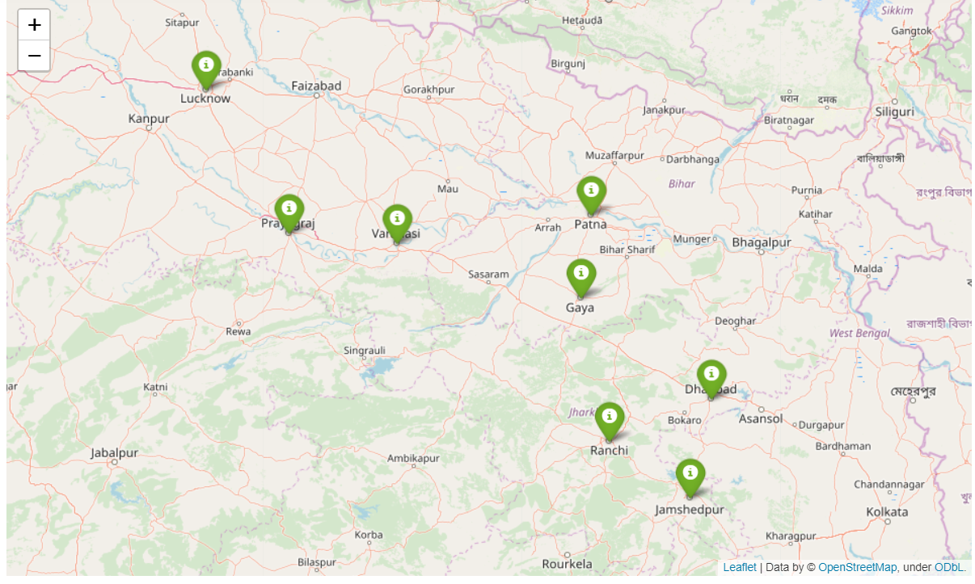

# **Objective**

In this project, we will use the Zomato API to study the cities. The aim of the project is to provide descriptive analysis of the city in terms of best resturants, cost of two etc.

This analysis will be useful for people (like students) who throng this city to decide upon the accommodation. Tourists will benefit while deciding on hotels to book.

# **Data**

The data for this project has been extracted using the Zomato API. The process in documented in the following [notebook](https://github.com/sukantoc/Coursera_Capstone/blob/master/Zomato_get_data_publish.ipynb).

The data that will be used after scrubbing can be found [here.](https://github.com/sukantoc/Coursera_Capstone/blob/master/india_zomato.csv)

The data from Zomato has been scrubbed and the following fields are only considered in the analysis:

Restaurant Name

Rating

Cost for 2 people

Latitude

Longitude

Data from Foursquare to be used are Latitude, Longitude, Venue Category and Venue Name.

# **Results**

The study was able to create clusters based on the data and it was plotted on the map as follows:

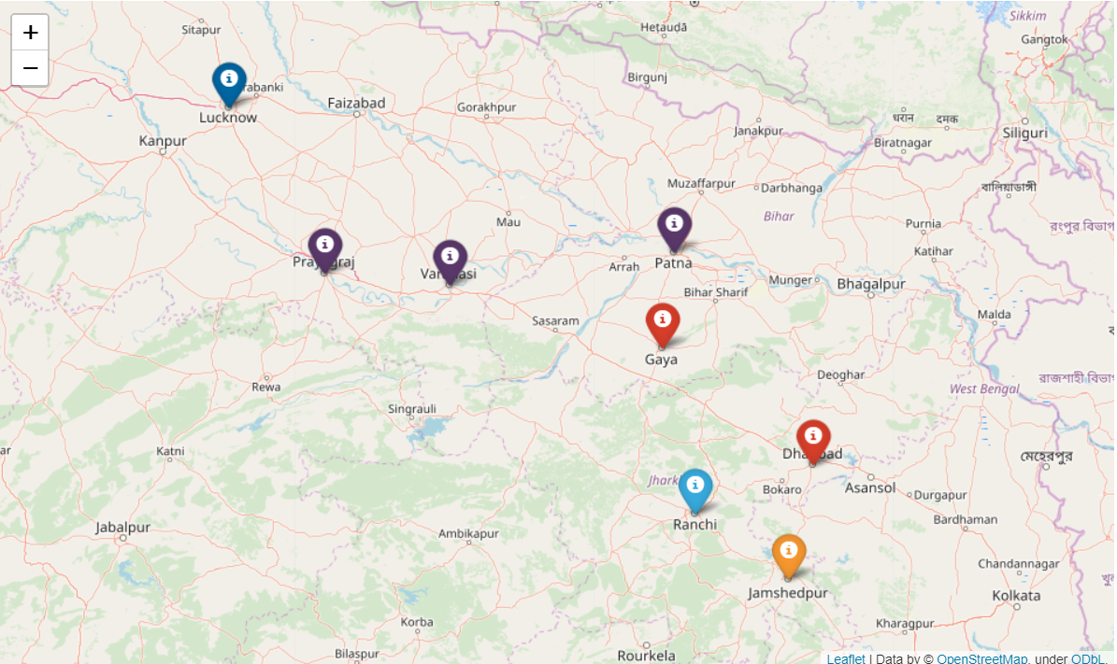

Also there was a descriptive based on the cost of two people and the ratings:

